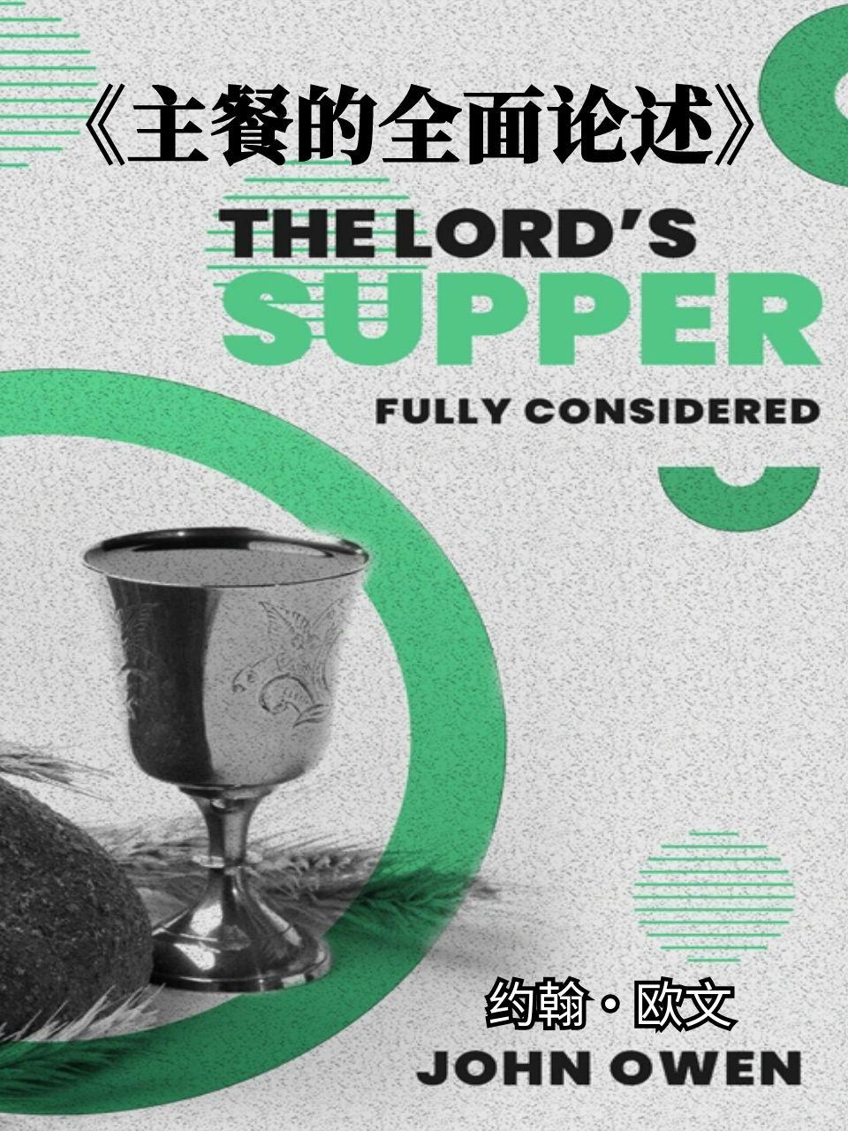

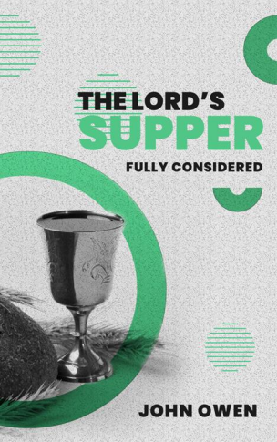

说明：
1、以下文字使用人工智能（claude)翻译，请以原文为准。
2、原文和翻译都可以免费使用，转发，传阅，复制，但不能商用，若商用，只能收回成本费。
3、若有更好的翻译，请来信指正，一同分享清教徒书籍，谢谢。

邮箱：xuanjiao789@outlook.com

The Lord's Supper
主的晚餐

Fully Considered
详考

by John Owen
约翰·欧文 著

PREFATORY NOTE

前注

IN 1798 a volume was published in Edinburgh under the title, "The lord's Supper fully Considered, in a Review of the History of its Institution; with Meditations and Ejaculations suited to the several parts of the Ordinance: to which are prefixed Three Discourses delivered at the Lord's Table; by the late Rev. John Owen, D.D."
1798年，一部书在爱丁堡出版，其标题为：「主的晚餐详考：对其设立历史的回顾；附有适合此圣礼各部分的默想与祷文：书前附有已故约翰·欧文博士牧师在主餐桌前发表的三篇讲道。」

It needs but a glance at the three discourses in order to feel assured, from internal evidence, that they belong to Owen.
只需对这三篇讲道稍作浏览，便可从内在证据确信，它们出自欧文之手。

The rest of the volume is assuredly not Owen's, as it consists of "Remarks on the 'Plain Account,' " etc.,—a work published long after onr author's death.
书卷的其余部分肯定不是欧文所著，因为它包含了「《简明记述》评注」等内容——这是一部在我们作者逝世很久之后才出版的著作。

These remarks are directed against a treatise of the celebrated Hoadly, bishop of Bangor, and latterly of Winchester.
这些评注是针对著名的霍德利（Hoadly）——先为班戈主教，后为温彻斯特主教——的一篇论文而作。

His treatise bears the title, "A Plain Account of the Nature and End of the Lord's Supper," and was published in 1735.
他的论文题目是「关于主的晚餐的性质与目的之简明记述」，出版于1735年。

An answer to it was published by Thomas Brett, LL.D., an English divine and controversialist; but whether his answer is identical with the "Remarks," we have failed to ascertain.
英国神学家及辩论家托马斯·布雷特法学博士（Thomas Brett, LL.D.）曾出版过一篇回应文章；但其回应是否与此「评注」相同，我们未能查明。

The three discourses subjoined are not of much importance, but as they have already appeared in print, we include them in this edition.—ED.
附录的三篇讲道并非至关重要，但鉴于它们已经印刷出版，我们将其收入本版。——编者注

DISCOURSE I

讲道一

JUNE 8, 1673.
1673年6月8日。

FAITH is bounded, in every ordinance, by its objects and acts.
在每一项圣礼中，信心都受其对象和行为的界定。

The general object of saving faith respecting God, is the truth of his word and promises, Rom. 15:8.
关于神，得救信心的普遍对象，是祂话语和应许的真理，罗马书 15:8。

The special object of our faith in this ordinance is the sufferings and death of Christ.
我们在此圣礼中信心的特殊对象是基督的受苦和受死。

Herein he is "evidently set forth crucified before our eyes."
在此，祂“明显地在我们眼前被钉十字架，展示出来。”

And we must act faith upon three things with respect to his death:—
关于祂的死，我们必须在三件事上运用信心：—

First, The personal love of Christ to our persons, from whence it was that he died for us.
首先，基督对我们个人的爱，祂为我们而死正是源于此爱。

So saith the apostle, "Who loved me, and gave himself forme," Gal. 2:20.
使徒如此说：“祂爱我，为我舍己，”加拉太书 2:20。

Were we helped to raise up our hearts by faith to apprehend Christ's love to our persons, it would greatly help us in this ordinance.
倘若我们蒙帮助，能藉着信心提升我们的心，去领会基督对我们个人的爱，这在此圣礼中将大大帮助我们。

The Lord lift us up above our fears, and give us a view by faith, not only of the love of Christ in general, but that be personally loved us, even this whole church!
愿主将我们提升到我们的恐惧之上，并藉着信心赐给我们一个看见，不仅看见基督总体的爱，更看见祂亲自爱我们，甚至爱这整个教会！

Secondly, The sufferings of Christ.
其次，基督的受苦。

In this ordinance we are to act faith upon his death, as therein undergoing the punishment due to our sins.
在此圣礼中，我们要对祂的死运用信心，视其为担当了我们罪所应得的刑罚。

It is [intended] to mind us that "he made his soul an offering for sin," that "he suffered for sin, the just for the unjust," "bearing our sins in his own body on the tree," that we should not come into judgment.
这是[为了]提醒我们，“祂使自己的灵魂作为赎罪祭，”祂“为罪受苦，义的代替不义的，” “亲身担当了我们的罪在木头上，”使我们不至受审判。

Thirdly, The effects of Christ's death; which were, tho making an atonement for all our sins,—the making peace between God and our souls, bringing in everlasting righteousness.
第三，基督之死的果效；即为我们所有的罪成就赎罪——在神与我们灵魂之间缔造和平，并引入永远的义。

Under the law we find that "the blood of bulls and of goats, and the ashes of a heifer sprinkling the unclean, sanctified to the purifying of the flesh," and that the people were thereby legally cleansed; "how much more shall the blood of Christ, who through the eternal Spirit offered himself without spot to God, purge our conscience from dead works to serve the living God?" Heb. 9:13, 14.
在律法之下，我们发现“公牛和山羊的血，并母牛犊的灰，洒在不洁的人身上，尚且叫人成圣，身体洁净，”并且百姓因此在律法上得以洁净；“何况基督藉着永远的灵，将自己无瑕无疵献给神，祂的血岂不更能洗净你们的心，除去你们的死行，使你们事奉那永生神吗？”希伯来书 9:13, 14。

The acts of faith in this ordinance are, first, recognition.
在此圣礼中信心的行为，首先是认知。

That faith which is exercised on the death of Christ, that is past, is to call it over, and make it present to the soul.
那运用在基督已逝之死上的信心，是要将其重新召回，并使其临在于灵魂之中。

It is to realize it and bring it before us.
是要实现它，并将其带到我们面前。

It is not a bare remembrance of it, but such a one as makes it present.
这不仅仅是对它的记忆，而是使其临在的记忆。

And where there is faith, there is the same advantage to a believing soul in the participation of this ordinance as there would have been if we had stood by the cross.
哪里有信心，哪里就有信徒在参与此圣礼时，如同亲身站在十字架旁一样的益处。

Secondly, Faith works by reflecting to humiliation.
其次，信心藉着反思引向谦卑。

"They shall look on him whom they have pierced, and mourn" for all their unkindness and unthankfulness to their Saviour.
“他们必仰望他们所扎的人，并且悲哀，”为他们对救主一切的无情和忘恩而悲哀。

And when we come to this work in this ordinance, self-abasement, self-abhorrence, and brokenness of heart, will be acted, and flow forth in abundance of love to Jesus Christ.
当我们在此圣礼中进行这项工作时，自卑、自憎和心灵破碎将会被激发，并涌流出对耶稣基督丰盛的爱。

Thirdly, Another act of faith in this ordinance is, thankfulness to God for his wisdom and grace in contriving this way of our salvation; and thankfulness to Christ, in whom was this mind, that, "being in the form of God, and thinking it not robbery to be equal with God, he took upon him the form of a servant, and became obedient unto death, even the death of the cross," that he might save us from our sins.
第三，在此圣礼中信心的另一个行为是，为神策划我们得救之路的智慧和恩典而感谢祂；并感谢基督，祂存此心，“祂本有神的形像，不以自己与神同等为强夺的，反倒虚己，取了奴仆的形像，成为人的样式；既有人的样子，就自己卑微，存心顺服，以至于死，且死在十字架上，”为要拯救我们脱离我们的罪。

If the Lord be pleased to lead us to act faith in any of these things, in some signal and eminent manner, we shall find an advantage in this ordinance.
如果主乐意引导我们以某种显著而卓越的方式在这些事上运用信心，我们将在此圣礼中找到益处。

————
————

DISCOURSE II

讲道二

TO help you in the exercise of faith in the administration of this ordinance, I would briefly show what it is to have a sacramental participation of Jesus Christ.
为帮助你们在此圣礼的施行中运用信心，我愿简要说明何为对耶稣基督圣礼性的分享。

When the world had lost the understanding of this mystery, for want of spiritual light, they contrived a means to make it up, very easy on the part of them that partake of it, and very prodigious on the part of the priest; for he, by a few words, turns the bread into the body of Christ, and the people have no more to do but to receive it as such into their mouths!
当世人因缺乏属灵亮光而失去对此奥秘的理解时，他们设计了一种弥补的方法，对领受者而言非常容易，对神甫而言则非常奇特；因为他，藉着几句话，便将饼变成了基督的身体，而人们只需将其如此领入口中即可！

It was the loss of the understanding of this mystery that put them upon that invention.
正是由于失去了对此奥秘的理解，才使他们想出那个发明。

There is, indeed, a figure or representation in this ordinance; but that is not all.
在此圣礼中，确实有一个象征或表征；但这并非全部。

When the bread is broken, it is a figure, a representation, that the body of Christ was broken for us; but there is also a real exhibition of Christ unto every believing soul.
当饼被擘开时，这是一个象征，一个表征，表明基督的身体为我们擘开；但同时也有基督向每一个相信的灵魂真实的展现。

This is distinct from the tender of Christ in the promises of the gospel.
这不同于福音应许中基督的赐予。

In the promises, the person of the Father is particularly looked upon as proposing and tendering Christ to us.
在应许中，父的位格被特别看作是向我们提议并赐予基督。

In this ordinance, as God exhibits him, so Christ makes an immediate tender of himself, and calls our faith to have respect to his grace, to his love, and to his readiness to unite and spiritually incorporate with us.
在此圣礼中，正如神展现祂，基督也立即将自己赐下，并呼召我们的信心去关注祂的恩典、祂的爱，以及祂与我们联合并属灵上合一的预备。

He tenders himself to us not in general, but under a special consideration,— namely, as having "made an end of sin," and done all that was to be done between God and sinners, that they might beat peace.
祂将自己赐给我们，并非笼统地，而是在一种特殊的考量之下——即，祂已经“除净了罪，”并且完成了神与罪人之间一切当做之事，使他们可以和睦。

Christ made a double presentation of himself, as the great mediator; —first, when he offered himself a sacrifice on the cross, for the accomplishing the work of man's redemption; secondly, when he presented himself to God in heaven, there to do whatever remained to be done with God on our behalf by his intercession.
基督作为伟大的中保，作了双重的呈献；——首先，当祂在十字架上献上自己为祭，为要完成人类的救赎工作；其次，当祂在天上将自己呈献给神，在那里藉着祂的代求，为我们作成一切在神面前尚待完成的事。

The intercession of Christ is the presentation of himself to God upon his oblation and sacrifice.
基督的代求是祂在献祭和牺牲的基础上将自己呈献给神。

He presents himself to God, to do with him what remains to be done on our part,—to procure mercy and peace for us; and he presents himself to us in this ordinance (which answers to that intercession of Christ above, and is a counterpart of it) to do what remains to be done on the part of God,—to give in peace, and mercy and the sealed covenant to us.
祂将自己呈献给神，为我们作成尚待完成的事——为我们求得怜悯与平安；并且祂在此圣礼中将自己呈献给我们（这与基督在天上的代求相呼应，是其对应部分），为要作成神那方面尚待完成的事——将平安、怜悯和盖印的约赐给我们。

There is this special exhibition or tender of Jesus Christ; and this directs to a special exercise of faith, that we may knowhow to receive him in this ordinance.
耶稣基督有此特别的展现或赐予；这引导我们进行一种特别的信心操练，使我们知道如何在此圣礼中接受祂。

And, first, let us receive him as one that hath actually accomplished the great work of making peace with God for us, blotting out our sins, and bringing in everlasting righteousness; secondly, as one that hath done this work by his death.
并且，首先，让我们接受祂为一位已经实际完成了为我们与神和好、涂抹我们罪愆、并引入永恒公义这伟大工作的主；其次，接受祂为一位藉着祂的死完成了这项工作的主。

It is a relief when we have an apprehension that Christ can do all this for us: but he does not tender himself to us as one that can or will do it, upon such and such conditions as shall be presented, but as one that hath done it; and so we must receive him if we intend to glorify God in this ordinance,—namely, as having blotted out all our sins, and purchased for us eternal redemption.
当我们领会到基督能为我们做这一切时，这是一种安慰：但祂并非以一位能够或将会根据所提出的某些条件来做这些事的主的身份将自己赐给我们，而是以一位已经完成了这些事的主的身份；因此，如果我们打算在此圣礼中荣耀神，我们就必须如此接受祂——即，祂已经涂抹了我们所有的罪，并为我们买赎了永远的救赎。

Let us act faith on Jesus Christ, as one who brings along with him mercy and pardon, procured by his death,—all the mercy and grace that are in the heart of God and in the covenant.
让我们对耶稣基督运用信心，祂是一位藉着祂的死带来了怜悯与赦免的主——所有在神心中和在约中的怜悯与恩典。

To have such a view of him, and so to receive him by faith, is the way to give glory to God, and to have peace and rest in our own bosoms.
对祂有这样的看见，并如此藉着信心接受祂，是荣耀神并在我们自己心中获得平安与安息的途径。

DISCOURSE III

讲道三

AUGUST 10, 1673.
1673年8月10日。

TO a due attendance on this ordinance it is requisite not only that we be in a spiritual frame, but that we endeavour to bring and fix our hearts to some special thoughts with respect to this special ordinance; wherein the principal act on the part of God, and the principal act on our part with respect to Christ, are gloriously represented.
要合宜地参与此圣礼，不仅需要我们处于属灵的框架中，而且需要我们努力使我们的心专注于对此特殊圣礼的某些特别思念；在此圣礼中，神方面的主要作为，以及我们方面关于基督的主要作为，都得到了荣耀的表征。

The great act of God with reference to Christ is the exhibiting of him.
神关于基督的伟大作为是展现祂。

God did two ways exhibit Christ:—
神以两种方式展现基督：—

First, There was, as I may call it, on the part of God, a legal exhibition of Christ, mentioned by the apostle, Rom. 3:25, 26, "Whom God hath set forth to be a propitiation through faith in his blood, to declare his righteousness for the remission of sins; that he might be just, and the justifier of him which believeth in Jesus."
首先，在神方面，有一种我可称之为律法性的基督展现，正如使徒所提到的，罗马书 3:25, 26：“神设立耶稣作挽回祭，是凭着耶稣的血，藉着人的信，要显明神的义；因为祂用忍耐的心宽容人先时所犯的罪，好在今时显明祂的义，使人知道祂自己为义，也称信耶稣的人为义。”

This I call God's legal exhibition of Christ, when he set him forth to undergo the curse of the law that we might be blessed.
我称此为神对基督律法性的展现，那时祂使基督出来承受律法的咒诅，使我们可以蒙福。

This setting forth of Christ is here represented in this ordinance when the bread is broken.
基督的这种展现，在此圣礼中当饼被擘开时得到表征。

And this is that which you may exercise your faith on in this ordinance, that as the bread is here set forth to be broken, so God, to declare his own righteousness, hath set forth Christ to be bruised and broken, to undergo the sentence of the law.
这就是你们在此圣礼中可以运用信心之处，即正如饼在此被擘开一样，神为了显明祂自己的公义，也使基督被压伤和破碎，以承受律法的判决。

Thus we have a gracious sight of God's holiness in this ordinance.
因此，我们在此圣礼中得见神圣洁的恩典景象。

Secondly, He doth exhibit Jesus Christ in the promises ot the gospel And it might be with some respect to this ordinance that the gospel invitations, which have the nature of promises, were in the Old Testament set forth by eating and drinking: Isa. 55:1, "Ho, every one that thirsteth, come ye to the waters, and he that hath no money; come ye, buy, and eat; yea, come, buy wine and milk without money and without price."
其次，祂在福音的应许中展现耶稣基督。并且，旧约中以吃喝来描绘具有应许性质的福音邀请，可能与此圣礼有些关联：以赛亚书 55:1，“喂！你们一切干渴的都当近水来；没有银钱的也可以来。你们都来，买了吃；不用银钱，不用价值，也来买酒和奶。”

God having provided Jesus Christ to be the food of our souls, he doth propose and exhibit him in the gospel as such.
神既已预备耶稣基督作我们灵魂的食物，祂就在福音中如此提议并展现祂。

And what a blessed representation is there hereof in this ordinance!
在此圣礼中，这是何等蒙福的表征啊！

Here God makes a visible tender of Christ, as exhibited in the promises of the gospel, for the life, food, and strength of our souls.
在此，神将基督作一可见的赐予，正如福音应许中所展现的，为了我们灵魂的生命、食物和力量。

To answer the promises, he here makes this tender unto us.
为回应这些应许，祂在此向我们作出这赐予。

Thus you the principal act of God in this ordinance is the exhibiting of Jesus Christ unto us.
因此，你们（看到）神在此圣礼中的主要作为是向我们展现耶稣基督。

The great act on our part, with respect to Christ, which is also represented in this ordinance, is the reception of him by faith.
在我们方面，关于基督的伟大作为，也在此圣礼中得到表征，就是藉着信心接受祂。

It is not enough that God hath set forth Christ to declare his righteousness, and in the promises of the gospel: unless we receive Christ, we shall come short of all the design of grace and mercy therein.
神已使基督出来显明祂的公义，并在福音的应许中（展现祂），这还不够：除非我们接受基督，否则我们将亏缺其中恩典和怜悯的一切计划。

"As many as received him, to them gave he power to become the sons of God, even to them that believe on his name," John 1:12.
“凡接待祂的，就是信祂名的人，祂就赐他们权柄，作神的儿女，”约翰福音 1:12。

If there be any thing that is tendered to you, unless you receive it, there is nothing done; things are but in the same state wherein they were.
如果有什么东西赐给你，除非你接受它，否则什么也没有成就；事物仍处于原来的状态。

Notwithstanding all the tenders that God makes of Jesus Christ, in both the ways mentioned, if there be not an act of faith in receiving him, we shall have no benefit by it.
尽管神以上述两种方式赐予耶稣基督，但如果在接受祂时没有信心的行为，我们将无法从中受益。

Now, can any thing be more lively represented to us than our receiving of the bread in this sacrament?
那么，还有什么能比我们在此圣餐中领受饼更生动地向我们表征呢？

but if we act not faith therein, it will be but a bare representation.
但如果我们不在其中运用信心，它就仅仅是一个空洞的表征。

Therefore, if we believe that God is in good earnest with us in the tender that he makes of Christ, let us not be backward on our part, that the sacrament rites may not be empty signs to us.
因此，如果我们相信神在赐予基督的事上是真心对待我们的，那么我们自己就不要退缩，免得圣礼的仪式对我们来说成了空洞的记号。

MONERGISM BOOKS
神恩独作论丛书

The Lord's Supper Fully Considered by John Owen, Copyright © 2019
约翰·欧文所著《主的晚餐详考》，版权 © 2019

All rights reserved under International and Pan-American Copyright Conventions.
根据国际及泛美版权公约保留所有权利。

By payment of the required fees, you have been granted the non-exclusive, non-transferable right to access and read the text of this e-book on-screen.
通过支付所需费用，您已获得在屏幕上访问和阅读此电子书文本的非独占、不可转让的权利。

No part of this text may be reproduced, transmitted, downloaded, decompiled, reverse engineered, or stored in or introduced into any information storage and retrieval system, in any form or by any means, whether electronic or mechanical, now known or hereinafter invented, without the express written permission of Monergism Books.
未经神恩独作论丛书明确书面许可，不得以任何形式或任何方式（无论是电子的还是机械的，无论是现在已知的还是将来发明的）复制、传播、下载、反编译、逆向工程、存储或引入任何信息存储和检索系统。

ePub, .mobi & .pdf Editions December 2019 Requests for information should be addressed to: Monergism Books, PO Box 491, West Linn, Oregon, 97068
ePub、.mobi 及 .pdf 版本 2019年12月 信息咨询请联系：神恩独作论丛书，邮政信箱 491，西林，俄勒冈州，97068

Table of Contents
目录

Prefatory Note
前注

Discourse I
讲道一

Discourse II
讲道二

Discourse III
讲道三

